LESSONS FROM THE EAST ASIAN DEVELOPMENT EXPERIENCE FOR PAKISTAN

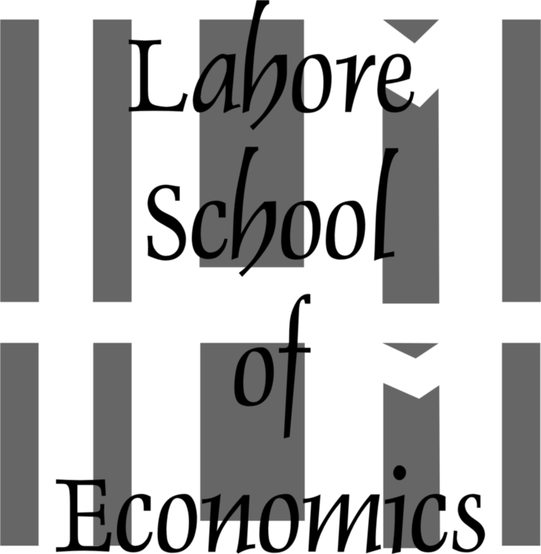

Sharmin Arif
Lahore School of Economics

This dissertation is submitted for the degree of
M.Phil Economics
2016

Supervised by:
Dr Hafiz Pasha

ABSTRACT
The thesis is a comparison of the historical experience of selected East Asian countries, namely Korea, Malaysia and Thailand, with Pakistan. The comparison has been conducted on certain identified key development markers of East Asia, which include non-economic and economic factors. It has been shown that East Asia focused on all aspects of development (economic and non-economic) with a priority towards coordination between the public and private sector to foster high-paced economic growth. Even though Pakistan followed similar economic policies, it could not sustain growth momentum in the absence of conducive environment to support consistent application of sound economic policy. Non-economic aspects of development were not prioritized or were completely ignored in Pakistan leading to erratic growth patterns and contrasting development outcomes. The thesis concludes that sustained, high and equitable economic growth results from applying a combination of economic and non-economic factors. Non-economic factors, namely, the Human Element in the roles of visionary leadership, competent bureaucracy, sound coordination between public and private institutions, trained and competent human resources and a culture that promotes cooperation and coordination between the citizenry and the state is crucial in the optimization of economic management of a country leading to sustainable development.

